

**LORAWAN PROJECT**

By:

Devomech Solutions Pvt. Ltd.

Date: 07-04-2023

# Current Progress:

* We have tested the rfm95 lora module for both client and server.
* The two-way communication was established between the client and server by defining the node address of all devices.
* The acknowledgement-based communication was tested in which the server send data to the different nodes (node 1 and node 2) and on successful transmission the client node send the acknowledgement message. On reception of the reply from client the data transmission is stopped elsewise the server keep on sending data to all nodes.
* The server and the client send wakeup/power on message to connected nodes so that the server resend the data in case of restart conditions triggered by battery drain or any other issues.

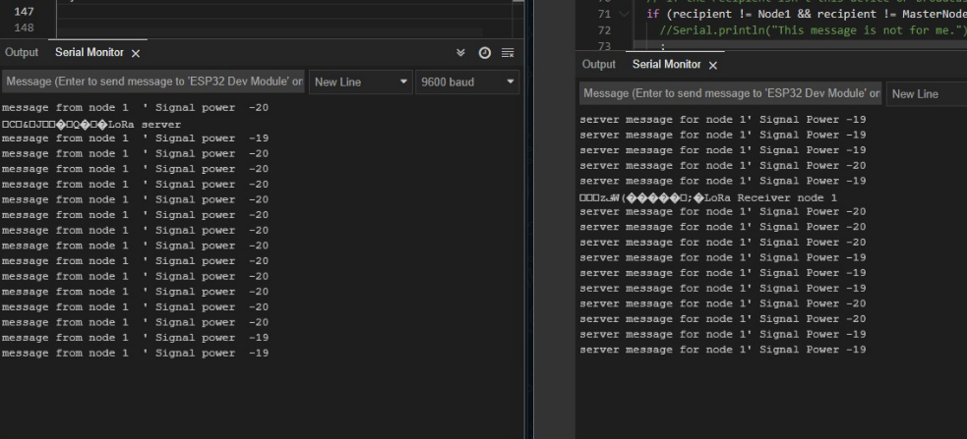

Figure 1 acknowledgement-based communication

# Task for Next Week

* Include the agriculture controller input signal code for both home and fields controllers.
* Test the sheild for arduino mega.